**CS 744 – Management Issues in Software Engineering Project Meeting**

Project title: Electronic Medical Records (EMR)

Group number: 2

Meeting #: 7

Held on: Mar 10, 2015 at 6:00 P.M.

Location: Murphy Library Group Room 204

Members of the group: Yufan Xue, Han Chen, Jingbo Chu

Members attended: all

Topic(s) for discussion: Implementation of rest of user stories (assignments).

Report writer: Yufan Xue

All members came on time and the meeting started on time

First, we reviewed what we did for this week,

For this week, we finished

1. Add a new transcription
2. View an transcription
3. Search drug
4. Add a new prescription
5. Add a new transcription

Yufan design the data table, which named transcription, and the table structure looks like this.

Jingbo and han reviewed the design, jingbo tested the web-services.

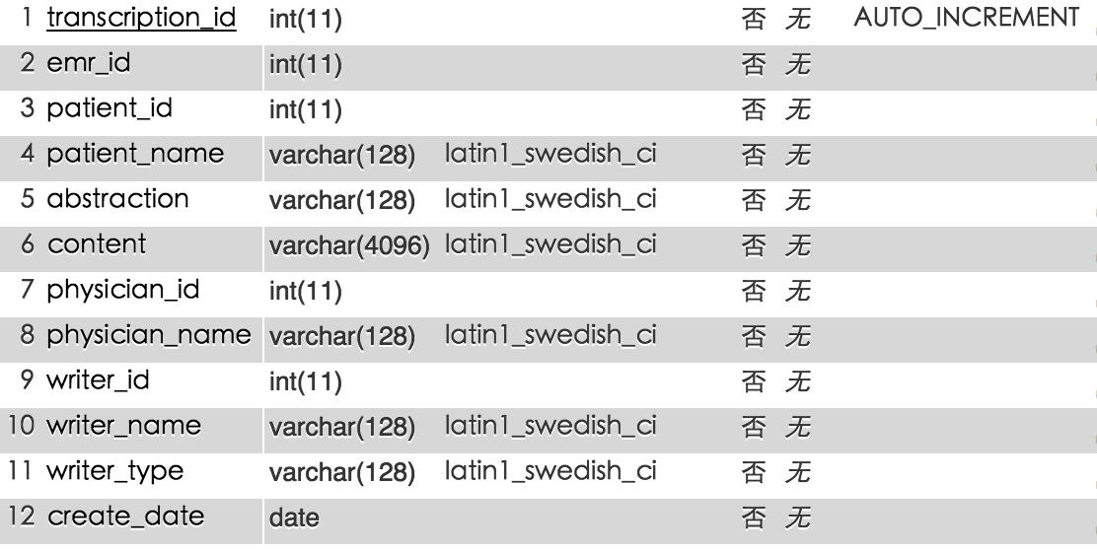

Yufan design the web pages and the server-end web-services.

User story: user could create a new transcription.

Url: /transcription/create

Parameter: emrId, patientId,

Logic: when user click the create button to create an transcription, front end js code will call back end service based on url upon, which insert an new transcription to database.

Url: /transcription/update

Parameter: transcriptionId, content, abstraction

Logic: when create a new transcription, function upon only insert a new record to database without transcription content, transcription abstraction, this function update the transcription.

1. View an transcription

Yufan design the web pages and the server-end web-services.

Jingbo and han reviewed the design, han tested the web-services.

User story: user can view transcription detail.

Url: /transcription/getTranscription

Parameter: transcription_id

Logic: user can view transcription detail by transcription id.

1. Search drug

Yufan design the web pages and the server-end web-services.

Jingbo and han reviewed the design, han tested the web-services.

User story: user can search drug by drug name.

Url: /drug/searchWithInput

Parameter: drugInput

Logic: user input the first part of drug name, and system will auto complete the remain part of the drug name.

1. Add a new prescription

Yufan design the tables and web pages and the server-end web-services, the data table looks like this.

Jingbo and han reviewed the design, jingbo tested the web-services.

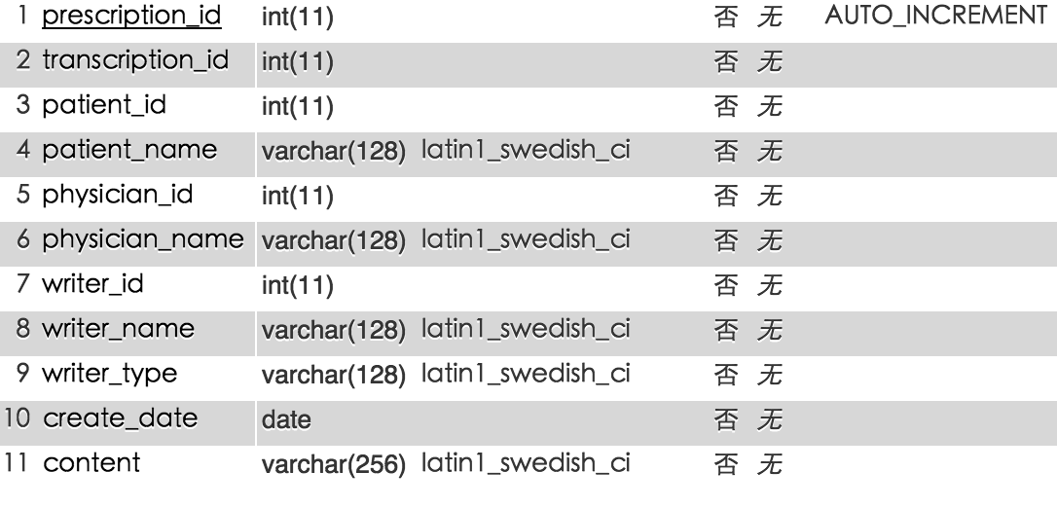

User story: user can add new prescription

Url: /prescription/add

Parameter: transcriptionId, patientId

Logic: user click create button, and create a new prescription associated with transcriptionId.

The next meeting will focus on remain functionalities of EMR system on Mar 17th